Why London?
Some say it’s the beauty of a city that has the Thames River running through it, with amazing parks and trails along the river bank. Others say it’s the appealing hotels, entertainment, unique shops, and sports facilities. Mostly, it’s the people – all the warm friendly people who make London a caring, welcoming city and the perfect host city for your next convention, meeting or special event.
London has…
- Meeting and hotel facilities to host groups of all sizes, large or small
- International airport access with direct flights from major Canadian and US cities
- Vibrant city lifestyle with small town warmth
- Many options for unique off-site venues and team-building events
- More than 3,500 rooms available including seasonal accommodations at Western University, Brescia University College, and Fanshawe College.
Just the right size…
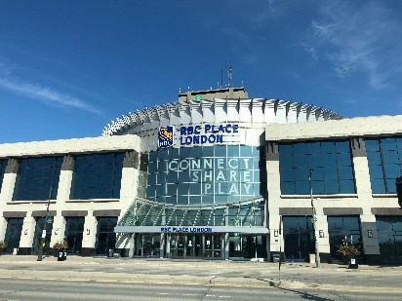
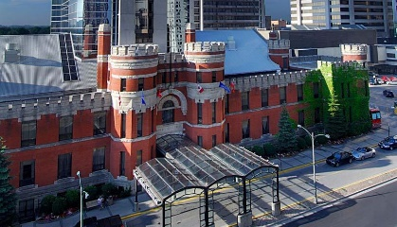
- Numerous options when selecting a host facility:
The Downtown Core:
- RBC Place London: 70,000 square feet of flexible meeting space & attached to the DoubleTree by Hilton by covered walkway
- DoubleTree by Hilton: 30,000 square feet of meeting space
- Delta London Armouries: 12,500 square feet of meeting space and only 180 steps from RBC Place London
Just minutes from downtown:
- Best Western PLUS Lamplighter Inn & Conference Centre
- Four Points by Sheraton London
- Western University

Getting to London is EASY!
- Fly to London: London International Airport is located just 15 minutes from the downtown core and will get your delegates here quickly and conveniently.
- Drive to London: Located at the convergence of highway 401, 402 & 403. 2 hours or less drive from most major Ontario cities and the USA border
- Train to London: VIA Rail Station is conveniently located downtown and 2 blocks from several major convention facilities and hotels
Contact Tourism London
At Tourism London, we are on your team and will help with everything from RFP distribution, site visits, and promotional materials. Large or small, London is the perfect destination for your next convention or meeting.
For more information, please contact
Karen Dowhan,
Director of Conventions
kdowhan@londontourism.ca
416.388.4905

